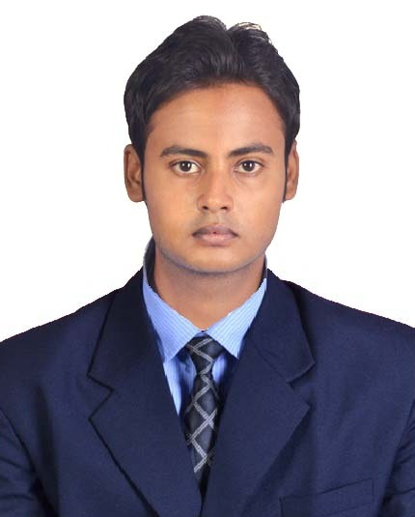
AKASH KARMAKAR

Computer Science & Engineering
Dhaneswar Rath Institute Of Engineering & Management Studies(DRIEMS)
Email : akash04karmakar@gmail.com, akashkarmakar@rediffmail.com
Contact No.: +91 9583240617
Website : www.akash04.com, www.meakash.com
Experience: 3 Years

Objective
Having 3+ years of experience in development of business applications and want to be a part of a challenging career opportunity where IT initiatives through strategic planning, proactive project management, decisive leadership, dynamic client relations, and targeted international marketing and business development can be effectively applied to achieve company objectives. To give my career a boost by joining eminent and highly professional company and contribute to the success of the company by outstanding performances and thereby advancing my career.

Educational Qualification
- Completed B.TECH from DHANESWAR RATH INSTITUTE OF ENGINEERING AND MANAGEMENT STUDIES in the year 2013 and got 7.12 CGPA till 8th semester.
- Completed 12th from Kendriya Vidyalaya, Surda in the year 2009 with percentage of marks 65.
- Completed 10th from St. Joseph’s Convent High School, Mosaboni in the year 2007 with percentage of marks 78.

COMPUTER PRoFICIENCY
- Technologies: Java, HTML5, CSS3, Bootstrap, SQL, PHP, Wordpress, JQuery, Javascript, Angular JS

- Applications: Adobe Photoshop, Adobe Illustrator, Adobe After Effects, Adobe Edge Animate,
Dreamweaver, Sublime Text, Microsoft Office.

Project Undergone
- Hand Gesture Recognition using Neural Network.

technical Seminar
- Emotion Detection through eye using Evolutionary Computing.

wORK EXPERIENCE
My City Deals – (July 2013 – June 2014) – www.mycitydeals.net.in

- Worked as Web Designer using technologies HTML5 and CSS3 to design static website templates.

- Graphic designing using Adobe Photoshop to make website PSD templates and graphic banner, logos, graphic ads for different website.

--------------------------------------------------------------------------------------------------------------------------------

SysWAY Technologies – (July 2014 – July 2015) – www.sysway.co.in

- Managed a team of 3 engineers.
- Train the new interns about the systems & software languages used in the organization.
- Responsible for resolving issues that affect any customers' web site functionality.
- Handled the various responsibilities in the absence of the Technical Lead.
- Developed plans & policies to facilitate better product delivery to customers.
- Successfully completed the Online Projects for the Domestic as well as International clients, within the stipulated time.
- Quick Learner with the ability to rapidly achieve organizational integration, assimilate job requirements and employ new methodologies.
- Excellent communication skills have always been an asset in completing business venture and projects with success.

- I have a good experience in Web Designing with HTML5, CSS3 and making Responsive Websites using Bootstrap 3. Check my website to get a better view on my portfolio (www.akash04.com)
The links for the recent sites designed and deployed are follows:-
(www.sysway.co.in, www.softronixtechnoware.com,www.ideemart.com)

- I have experience in Web Development using PHP and MySQL.
The links for the sites designed and deployed are follows:-
(Industrial Software Solution - iss.syswaydemo.com, Health Care Solution - www.carepluszambia.dyndns.org, Retail Management – retail.grotap.com)

- I have experience in developing websites Wordpress & making E-Commerce Website using WooCommerce Integration.
The links for the sites designed and deployed are follows:-
(www.brandnewagain.com, www.kaushikvichar.com,www.grotap.com)

- I have a good experience in using Photoshop and Illustrator for Logo Designing, Icon Designing, PSD to HTML Conversion, Banner Designing and all sorts of Graphic Designing works.
Check my website to get a better view on my portfolio (www.akash04.com)

- I also design creative and unique Website Templates using Photoshop and have experience in converting the PSD designs to HTML.

-----------------------------------------------------------------------------------------------------------------------------

Future Focus Infotech – ( September 2015 – Continuing) – www.focusinfotech.com

- Currently working as UI Designer using technologies HTML5, CSS3,JQuery, Javascript to make Responsive Portals Applications – Tata Communications.

- Making Non-Responsive web portal application Responsive to make them compatible with all Mobile devices using Boostrap3.

STRENGTH
- Focused in my work, punctual in time and hard worker.
- Ability to manage time and take decision in critical situations.
- Willingness to learn new technologies.
- Energetic and Self Motivated team player/builder.
- Having good logical reasoning ability, coordination and interpersonal skills.

ACHIEVEMENTS
- Won 1st Prize in Computer Gaming Tournament in year 2011.
- Completed and Delivered all Projects before deadline.

Hobbies & interests
- I like to listen music.
- I like to play guitar.
- I like to spend time playing computer games.

Personal Information
Date of Birth : 08-01-1991
Sex : Male
Father’s Name : CHANDAN PRAKASH KARMAKAR
Nationality : Indian
Marital Status : Single
Languages Known : English, Hindi, Bengali

Present Address:
Qr No. JSF – 10, Tumandungri,
P.O. – Moubhandar, Ghatsila
Dist – East Singhbhum,
Jharkhand, India
Pin - 832103
Permanent Address:
C/O – Kamala Kanta Karmakar,
Gopalganj, Sastibortala,
P.O. – Bishnupur,
Dist - Bankura, West Bengal, India
Pin - 722122

Declaration

I hereby declare that the information furnished above is true to the best of my knowledge.
Signature:

